MVC Architecture
- 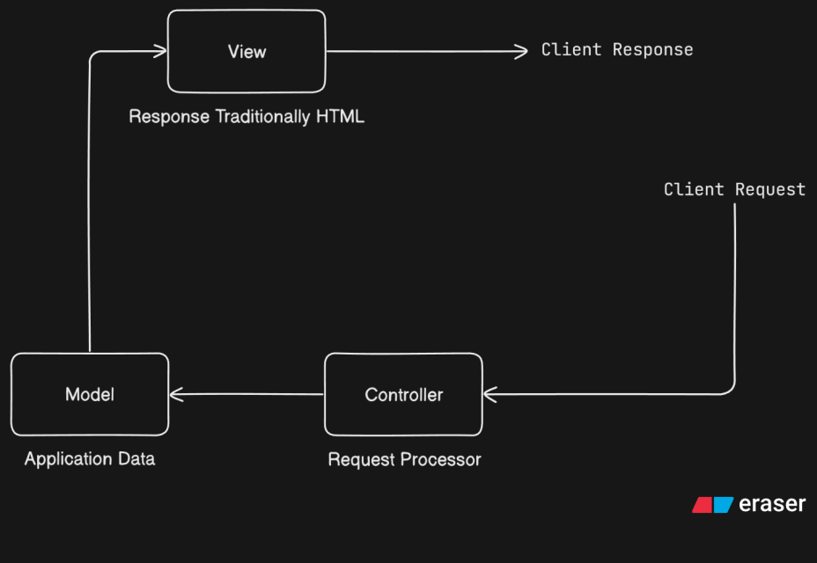
  - Controller
    - Different APIs (Get, Post etc) will be having different controller
  - Model
    - Handling the data
    - Talking to Database
    - In case of Java, Model is present in the Object
  - View
    - HTML or JSON
    - Send the data to the client
- Spring MVC (Legacy)
  - 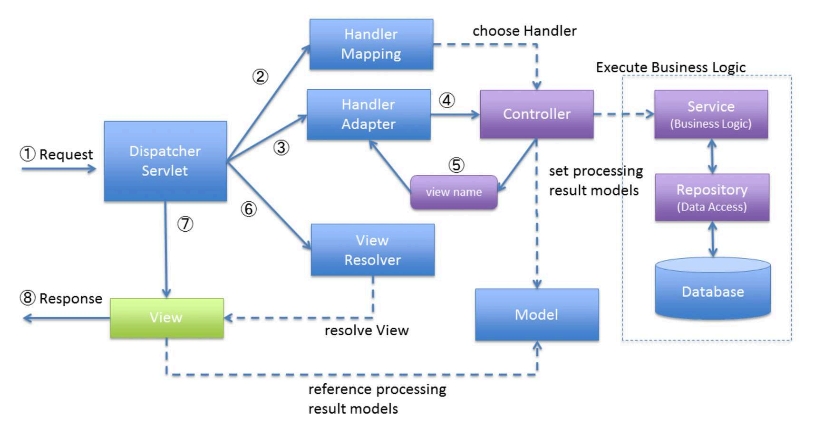
  - View Resolver will take a look at the Dispatcher Servlet that which kind of user has requested and then it converts the Model to that format i.e. XML, HTML, JSON etc.
- Spring MVC (Modern)
  - 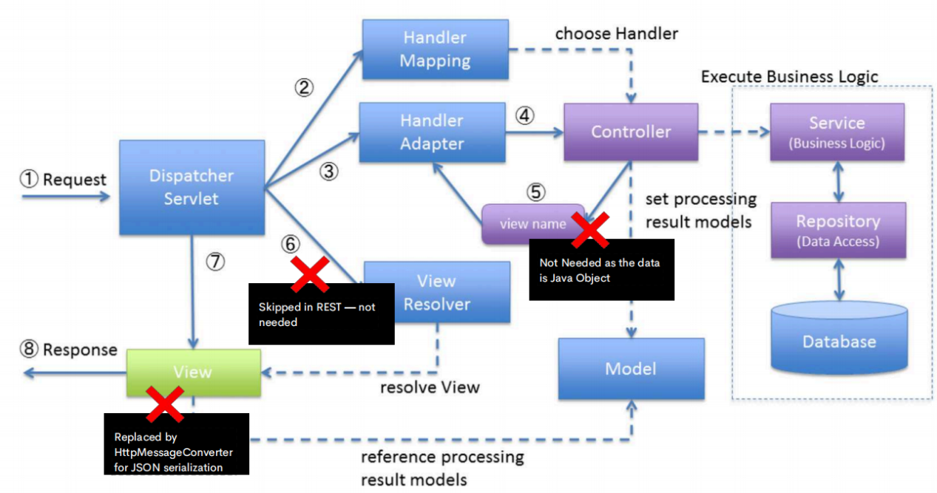
  - In recent times, JSP is not used.
  - React or Angular etc are used to create Frontend and use Spring to create JSON.
- How does a Web Server works in Spring Boot?
  - 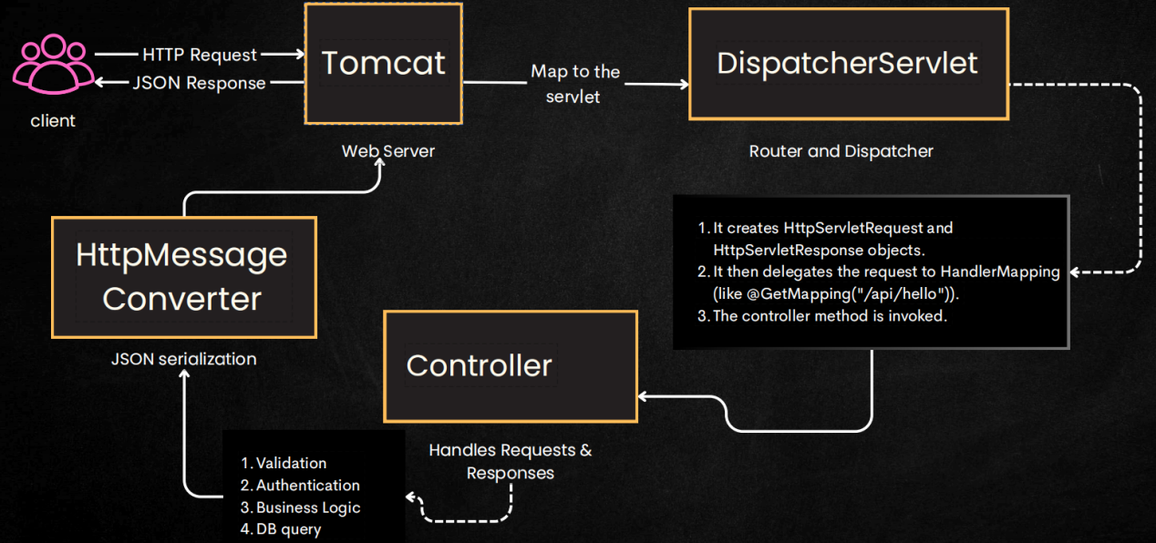
  - The client request cannot go to the Dispatcher Servlet directly as it’s a Java/Spring entity and not able to handle http request directly.
  - So the request go to a web server (tomcat, jetty etc.. Spring Boot uses Tomcat by default) and then it transfer those requests to Dispatcher Servlet.
  - We can have multiple requests like profile request or admin request or reels request etc etc. So these routing part is done in here i.e. Dispatcher Servlet.
    - 2 Objects i.e. HttpServletRequest and HttpServletResponse are created in this part only.
    - In that HttpServletRequest contains everything like headers, query, ids params.
    - After doing the things, we can update the HttpServletResponse and return it as the response.
  - 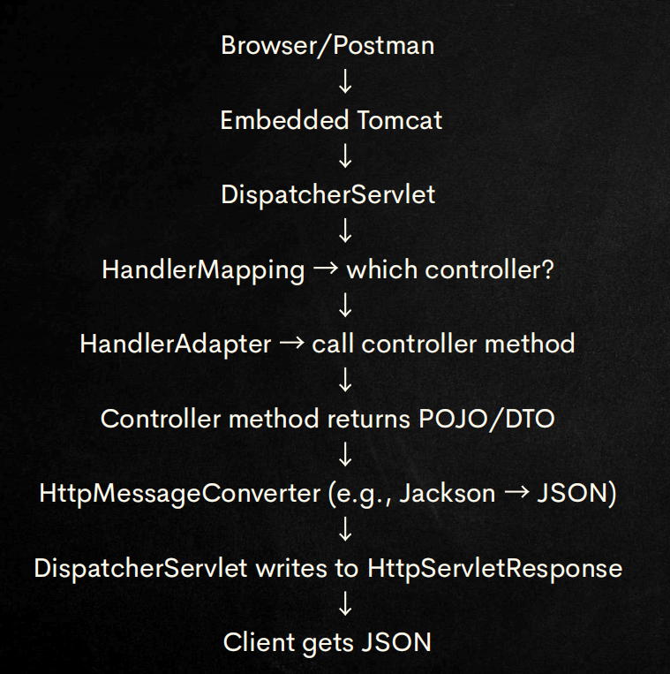

- 3 layered architecture
  - 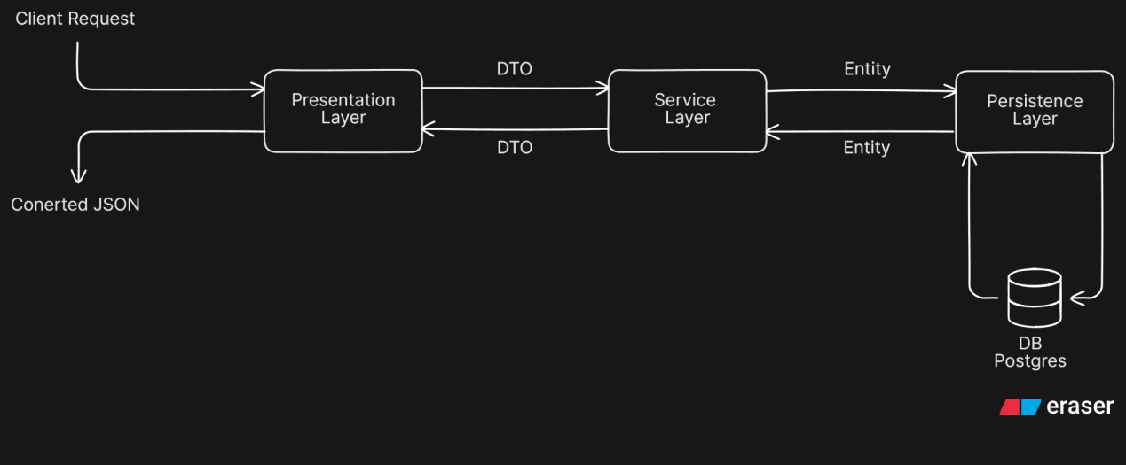
  - Layers
    - Presentation Layer (Handle Request and Response)
      - Request from client will be handled by this
      - Communication between Presentation and Service layer happens with transfer of DTO (Data Transfer Object)
      - Lets say user is trying to login, so payload of the request may be containing username, password, email etc.. those things will be converted to an Object (DTO) and sent to the Service Layer.
    - Service Layer (Business Logic)
      - It’ll check the things like is the user is valid with the help of Persistence Layer.
      - Service and Persistence layer have conversation by transferring Entity.
    - Persistence Layer (Data Access Layer)
      - It has only the access to database.
      - So, Service layer verifies the things with the help of this Persistence layer only.
  - In simple terms: A DTO is the structure received from (or sent to) the user in API requests/responses, and an Entity is the structure used to store data in the Database.”

Presentation Layer
- 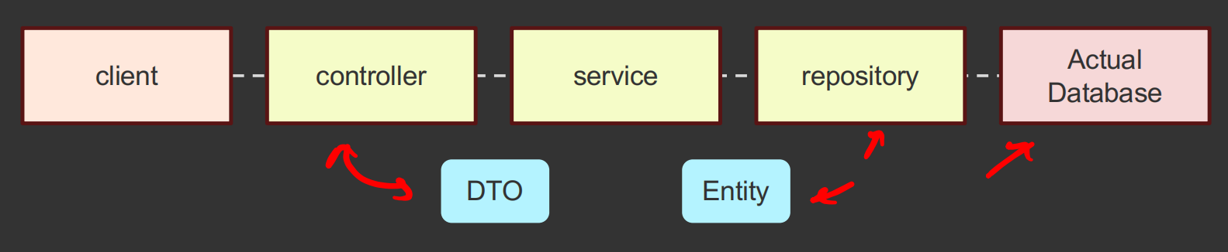
- @RestController
  - It marks a class as a REST controller and automatically applies @ResponseBody to every method.
  - 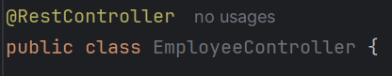
  - You can see in the @RestController, it has one annotation called @ResponseBody
    - 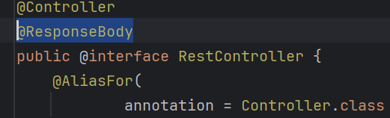
    - It ensures the returned Java object is converted to JSON/XML and written to the HTTP response body using message converters.
  - To convert incoming JSON/XML to Java objects, Spring uses @RequestBody, not @ResponseBody.
  - If you write @Controller instead of @RestController then it’ll think “user is the name of a view template (i.e. User.jsp, User.html) and it’ll try to load the UI page and fail”.
    - To make it return JSON then you need to write @ResponseBody in each method.
- NOTES
  - Spring MVC provides an annotation-based programming model where @Controller and @RestController components use annotations to express request mappings, request input, exception handling, and more.
  - The @RestController annotation is a shorthand for @Controller and @ResponseBody, meaning all methods in the controller will return JSON / XML directly to the response body.
  - With @RestController, we don’t need to explicitly write @ResponseBody for each methods to make it return JSON. (But with @Controller we need to write explicitly).

- Request Mappings
  - You can use the @RequestMapping annotation to map requests to controllers methods. It has various attributes to match by URL, HTTP method, request parameters, headers, and media types.
  - @GetMapping, @PostMapping ..etc are there for GET, POST, ..etc type of requests.
- See the below code
  - 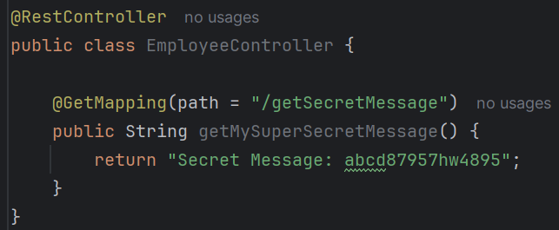
  - Now this path “/getSecretMessge” is exposed.
  - But the question is how was it become live just by writing the code here? We didn’t even used this method anywhere to make it live.
    - So, as we discussed earlier, Component Scan happens for all the files present on the same or child directories where the main method file is placed.
    - @RestController contains @Controller inside it; and @Controller contains @Component inside it.
    - It’ll check for all the annotations and makes Bean out of those directly and use.
- To create the DTO, there is no specific annotations.
  - 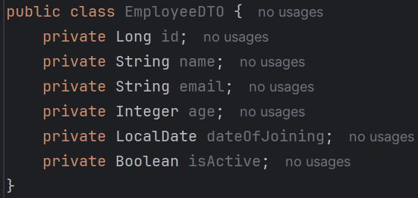

- See the below use cases to pass params in URL
  - 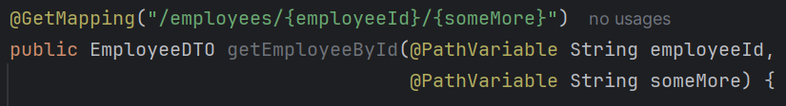
    - If you see here I have set the argument names in the method same as the params name in the URL.
    - If you give different names then it’ll not work.
    - The fix for this i.e. if you want to give different argument names then use @PathVariable(“real-param-name”) DataType newArgument
    - 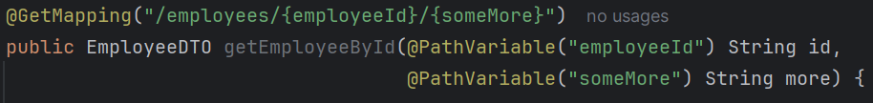
  - You can see the output will be in JSON format even if we didn’t explicitly convert this to JSON.
    - 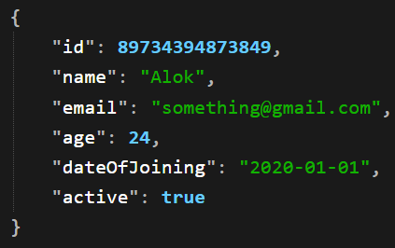
    - There is a library jackson which does this things.
- To get the query values, use the annotation @RequestParam
  - The URL should be like: /employees?age=40 (something like this)
  - But if you open only /employee it’ll not load the page
  - 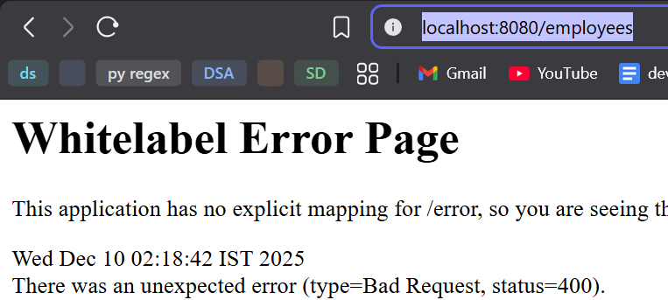
  - It is because the query param is mandatory here.
  - We need to make it optional. @RequestParam(required = false)
  - Now you can see the page is loading
    - 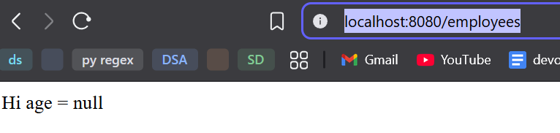
- Instead of writing /employees everywhere, we can set the path for @RequestMapping at the top level.
  - 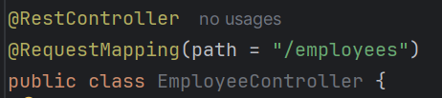
  - Now you don’t need to write /employee in every methods.
  - 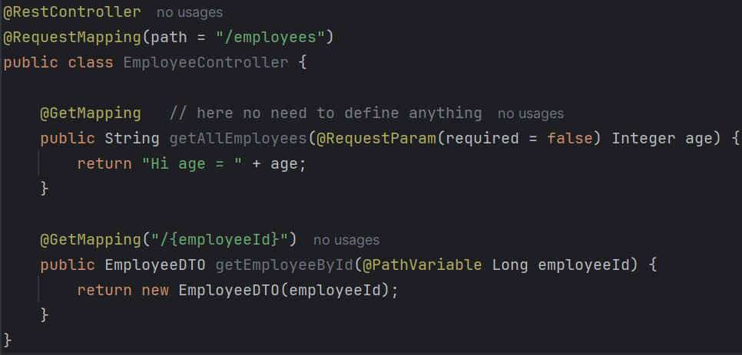
- Other mappings are also there: @GetMapping, @PostMapping, @PutMapping, @DeleteMapping, @PatchMapping
- There are so many @Request annotations to get the query, body, header etc etc.
  - 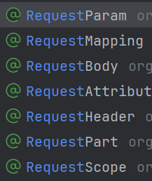

------------------------------------------- SOME POINTS ---------------------------------------
- There is a dependency called lombok which provides getters, setters, constructors by default. No need of defining this by our own.
  - 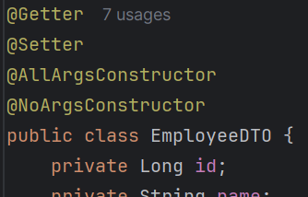
- spring.datasource
  - It is a spring boot configuration property used to set up database connection.
  - It tells spring boot:
    - Which database to connect to
    - How to connect
    - Which driver to use
    - Database username & password.
  - 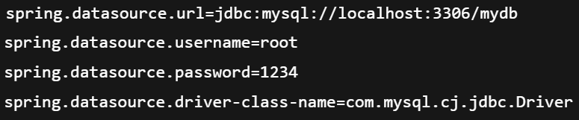
- Presentation Layer, Service Layer, Persistence Layer
  - These 3 are just architectural patterns. It has nothing to do with spring/spring boot framework.
  - Spring Boot just makes it easy to implement these architectural patterns.
  - Spring Components for the Layer
    - Presentation -------- Controller ( @RestController )
    - Service --------------- Service ( @Service )
    - Persistence ---------- Repository ( @Repository )
  - This is how the work happens between each layers.
- 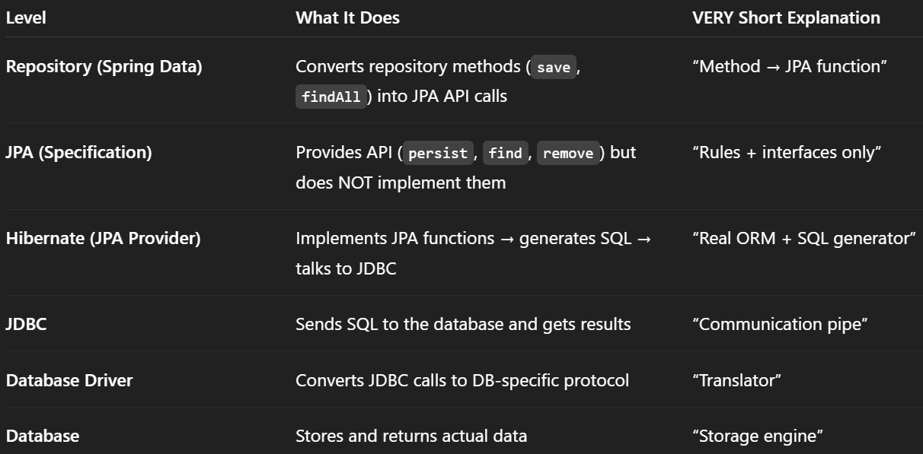
  - You call high-level functions (save(), findAll())
  - Spring Data + JPA + Hibernate automatically generate optimized SQL for you
----------------------------------------------------------------------------------------------------

- WORK-FLOW FROM REPOSITORY TO DATABASE
  - There are two levels in Spring Data JPA:
    - Repository level
    - EntityManager (JPA) level.
  - JPA itself consists of only interfaces (no implementation) and the EntityManager API.
  - When we call a repository method like findById(), Spring Data JPA creates a proxy implementation of the repository interface that contains implementations of high-level methods (findAll, findById, save, etc.).
    - Proxy implementation means Spring creates a class at runtime that acts as the real implementation of your repository interface — even though YOU never wrote that class.
    - It takes the implementations from a class called SimpleJpaRepository which has implementation of all the abstract methods of JpaRepository interface.
  - That proxy internally delegates to the EntityManager, which triggers low-level JPA operations such as persist(), merge(), find(), and remove().
    - These methods are low level
    - It is there in between Repository and Hibernate level
  - Up to this point, everything was at the JPA level (only rules + API, no actual SQL).
  - Next, the call goes to the JPA provider (Hibernate).
    - Hibernate implements JPA and converts entity operations into actual SQL queries.
  - After Hibernate generates SQL, it sends the SQL to JDBC.
  - JDBC is responsible for:
    - creating/maintaining a secure connection to the database, and acting as the transport layer to send Hibernate’s SQL to the database driver.
  - Finally, the database driver sends the SQL to the database server for execution.

Persistence Layer
- 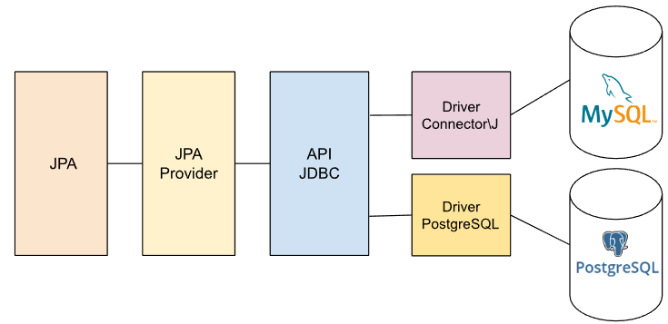
- JPA: Java Persistence API, nowadays its called “Jakarta Persistence API”
- Databases are also some servers but they hold some unique logic so that they can hold some data and query through it.
- Databases provide JDBC (Java Database Connection) drivers. Java uses JDBC to communicate with the database using those drivers.
- JPA is a specification. Hibernate is the most commonly used JPA provider that actually performs ORM (object–relational mapping).
  - Object-relational mapping means JPA works with Java objects, the database works with tables, and the JPA provider (like Hibernate) maps the Java objects to the database tables and vice versa.
  - We can imagine JPA as a set of rules, and a JPA provider as the implementation of those rules.
  - JPA defines interfaces and abstract classes that describe how entities should be mapped, persisted, and managed.
  - But JPA itself does not contain actual persistence logic.
  - A JPA provider (like Hibernate) implements those rules and performs the real work such as generating SQL, mapping objects to database tables, managing relationships, and handling transactions.
- JPQL
  - It is an object-oriented query language used in JPA to query entities, NOT database tables.
  - You write queries on entity classes, not table names
  - You use field names, not column names
  - It works on Java objects, not database records
  - The JPA provider (Hibernate) converts JPQL → SQL internally
- In simple terms:
  - JPA = What to do (not how to do it)
  - JPA Provider (Hibernate) = How to do it
  - JDBC = The pipe through which SQL is sent to the DB
  - Driver = Translator for a specific database
  - Database = The storage engine
- @Entity is used to define a class as an entity.
  - 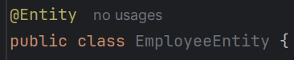
  - It’ll just tell the Spring Data JPA (Hibernate) that “this is the Java class. You need to convert it to table and store in the database”.
  - 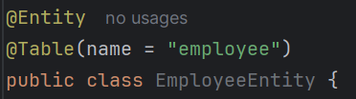
    - If you don’t give that @Table then it’ll create the table with name EmployeeEntity
- There are annotations to define the SQL things. For example:
  - 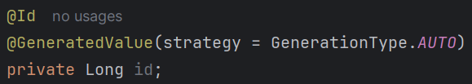
  - Here @Id means Primary Key in SQL.
  - @GeneratedValue with strategy means the strategy of incrementing the Id.
  - Different databases like mysql, postgres are having different type of strategy. So I selected AUTO so that it’ll work everywhere.
- After creating the Entity, you need to create the Repository.
  - The annotation will be @Repository.
  - 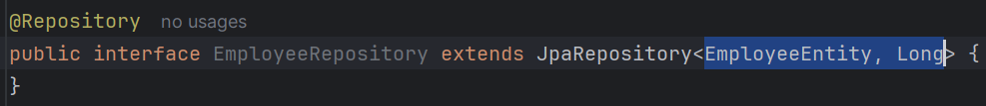
  - You need to extend JpaRepository (which is an interface) which is having all the definitions of methods like findAll, findAllById etc etc.
  - Basically JpaRepository provides set of CRUD operations and query methods.
    - Generic Interface
    - Predefined Methods
    - Custom Queries
  - Here the type which has to be passed to JpaRepository generic will be:
    - 1st one is type of entity
    - 2nd one is type of primary key (@Id)
  - The @Repository is containing @Component so bean will automatically be created by Spring.
- 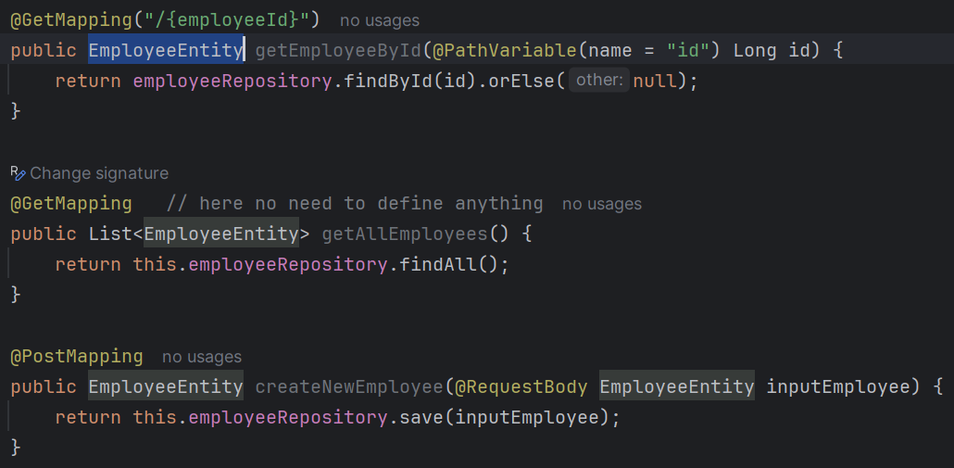
  - Created some controller methods inside the EmployeeController class using EmployeeEntity.
  - But this shouldn’t be done; Repository part and Controller part should not be mixed up.
  - I have used the dependency h2 which is used to simulate database things without using a real database.
  - If Entity class has private variables and you have not defined Getters and Setters then you will not get the result because it’ll not be able to get those values.
- You can see in the terminal
  - In between the URL link, there is something “mem” ; it means it’ll store the entries in the memory till the application is running.
- spring.jpa.hibernate.ddl-auto tells Hibernate how to handle your database tables when the application starts.

Service
- It will be having access to both DTO and Entity.
- As it’ll fetch the things from Repository, so it’ll be in the form of Entity. But whatever it’ll return, that will be going to Controller layer, so that return type should be of type DTO (not Entity).
  - To convert this, we can get the values of Entity one by one, then create one DTO type of object and return.
  - Or we can take help of the dependency: “modelmapper”
- As we need to convert Entity to DTO or vice-versa, so ModelMapper object will be used multiple times.
  - Its better to create one Bean of that and use that everywhere.
  - So, create one class MapperConfig and write the @Configuration and @Bean there.
  - 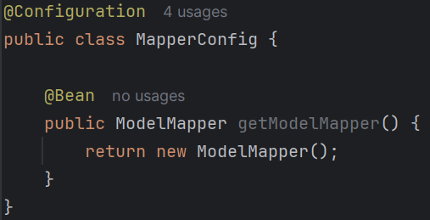
  - Now make sure, Controller part will be using DTO; Repository part will be using Entity; and @Service will be used to map those 2 properly depending upon the usage.
  - 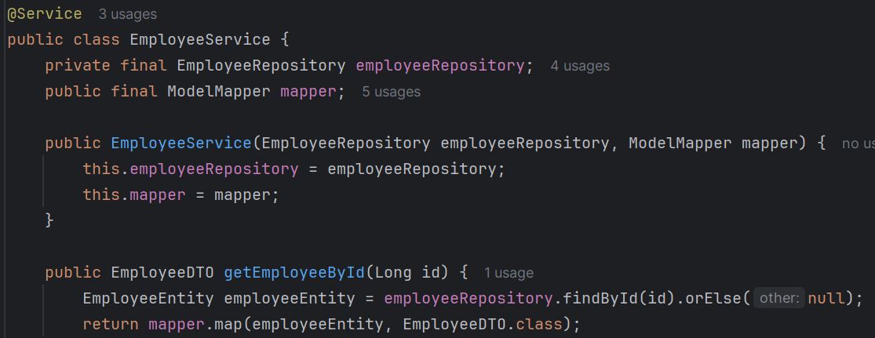

- Understand the flow
  - We have 3 things: Controller, Service, Repository
  - Usage
    - Controller uses DTO
    - Service uses both DTO and Entity
    - Repository uses Entity
  - So, the requests (Get, Post, Put, Patch, Delete) comes to controller. It’ll get the data as DTO object (if payload is there) using @RequestBody annotation.
    - Then it’ll pass that DTO object (if present) to Service.
    - If DTO is not there, it’ll simple call the Service method.
    - So, Controller will be having objects of DTO and Service.
  - Now It’ll come to Service layer
    - Service layer has access to Repository.
    - Here it’ll be having some business logic and it’ll then send the request to Repository.
    - So, Service will be having objects of DTO (to convert Entity to DTO), Entity (return type of Repository methods), Repository
  - Now it’ll come to Repository
    - We don’t have to write any methods inside the Repository (till not its an interface only) as everything is already there.
    - So, there is no need of doing anything in the Repository layer.

- @PutMapping
  - Controller
    - 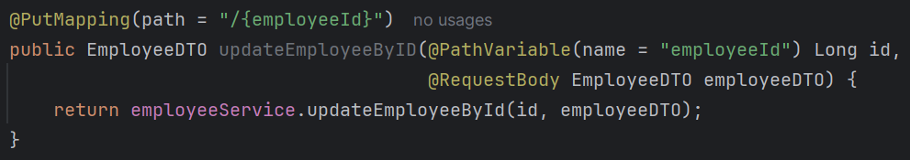
  - Service
    - 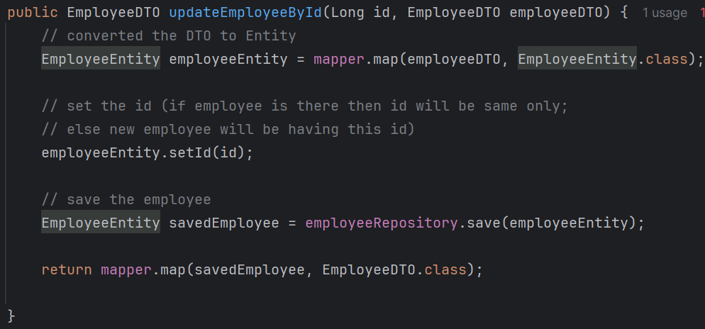
  - In PUT the whole object body should be updated; not partial
  - Simple concept is:
    - Getting the data payload (i.e. DTO)
    - Setting the id of this
      - In this case, if object is already there in the database then it’ll update the id of that entry
      - If the object is not there, it’ll create one new entry in the database
  - Now just save the new updated employee.
  - In this case, if you give partial values then other values in the database will become NULL.

Reflection in Java
- Lets say we have created one object of a class. When we call the method getClass() it’ll return the class object of the class out of which the object is created.
  - For example: lets say the class name is Car and we created one object carObj.
  - carObj.getClass() will give the object of Car class which is Car.class
- The class object is used for reflection.
- Reflection means inspecting/modifying classes at runtime.
  - Reading fields
  - Modifying fields
  - Invoking methods
  - Listing constructors
  - Creating objects dynamically
  - Reading annotations
- Sometimes you’ll get some object at runtime, but you don’t know which class does that belong to.
  - In that case you can use ? type generic
  - 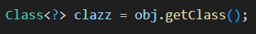
  - 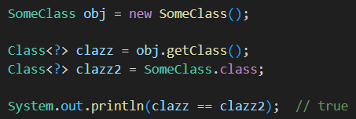
- There are 2 fields: getField() and getDeclaredField()
  - getField()
    - It can only access public fields.
    - It searches for the field in super classes as well.
  - getDeclaredField()
    - It can access all type of fields.
    - It doesn’t search in super classes.
  - In the class, name is a private field of type String.
  - getField() will not be able to get this. But getDeclaredField() can access this.
- 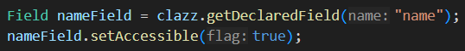
  - Now, I extracted the field name from the class using getDeclaredField()
  - Then I set it accessible using setAccessible(true) method.
  - setAccessible(true) doesn’t make the field public. It just allows you to read/write after getting it.
  - 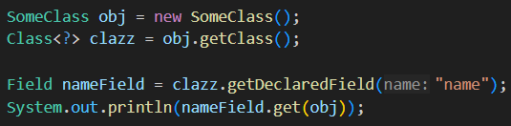
    - This will give error because the name field is private.
  - 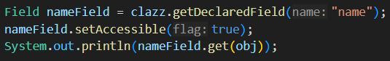
    - Now it can be accessible because we made it accessible using the method setAccessible.
- I have written 2 private methods in the class named as display and randomMethod
  - 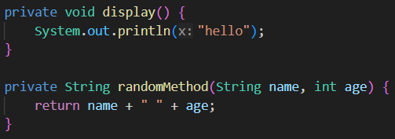
    - Both are private
  - 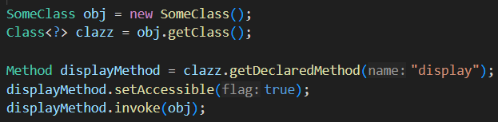
    - Here I am getting the display method using the function getDeclaredMethod() and making it accessible
    - Then invoke means it’ll run the function. You need to pass the instance of the class if it’s a non static method.
  - 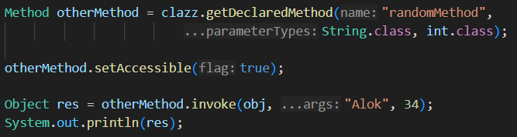
    - As the other method is returning something and also it has some arguments, so we need to pass the class object of all the arguments.
      - Here String.class, int.class
    - And the invoke method returns a Object type value so the res is of type Object.
    - We can also downcast here.
      - 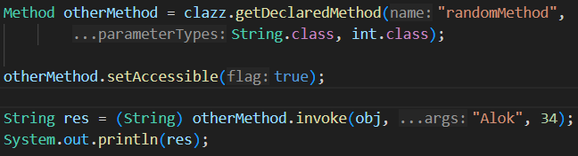
- Reflection in Spring
- Spring uses reflection to inspect classes, discover annotations, create objects, inject dependencies, and call methods — all at runtime.
- Dependency Injection
  - 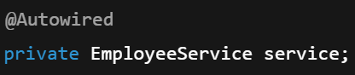 (we write like this)
  - 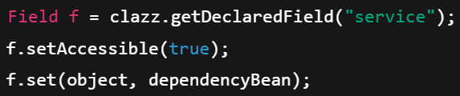 (internal of spring)
- Reading Annotations
  - 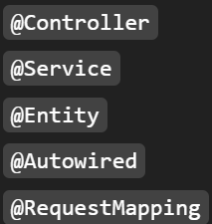 (we write these)
  - 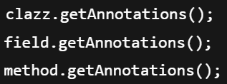 (spring does this)
- ReflectionUtils is a Spring utility class that makes using Java Reflection easier, safer, and cleaner.
  - Java Reflection = raw, low-level, verbose
  - Spring ReflectionUtils = wrapper that simplifies reflection
- Comparision
    - Spring ReflectionUtils
    - Java Reflection
- Some advantages of Spring ReflectionUtils over Java Reflections
  - It handles exceptions by itself
  - It marks setAccessible(true) by default
  - Handles super class traversal as well.
  - Provides iteration helpers
    - 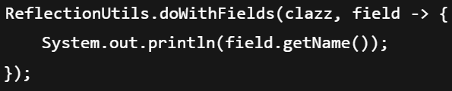

- @PatchMapping
  - Approach-1 (my approach)
  - In PATCH some part of the object should be updated; not full
  - 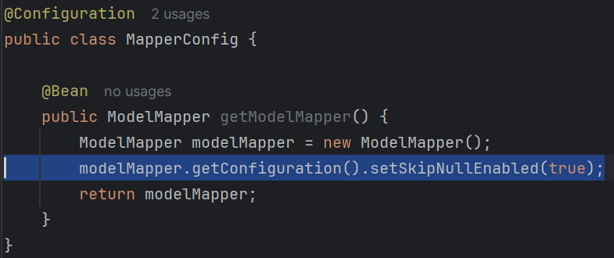
  - I added one line here. It means, if I am transferring the new values from new object to old object, then the null values of new object will not be updated in the old one.
    - Lets say in my database, the user’s entry is there.
    - But I want to update the specific values that are being sent in the patch request.
    - If I directly update then it’ll update the null values as well.
  - 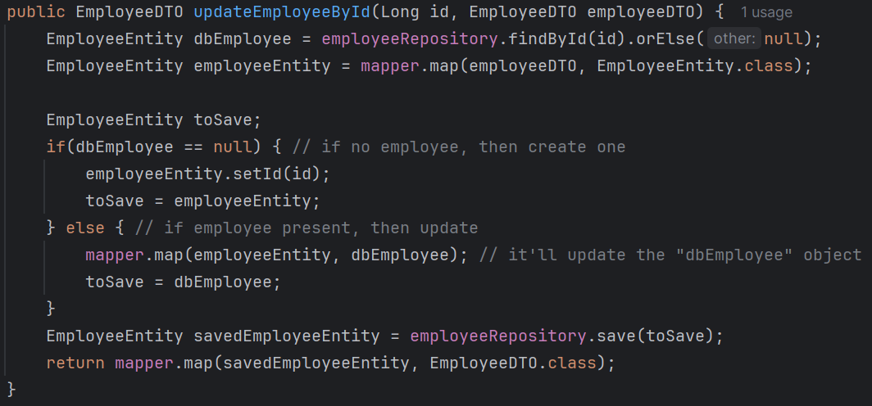
    - This is the function to update the employee .
    - It is written inside the Service.

  - Approach-2
  - 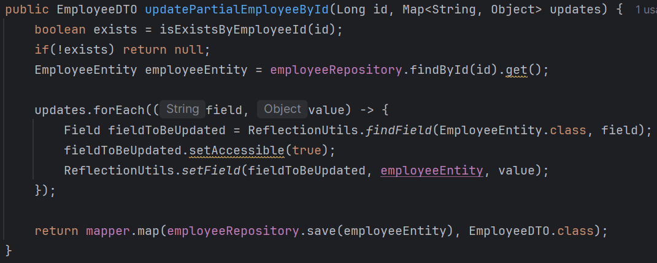
    - Service method
  - 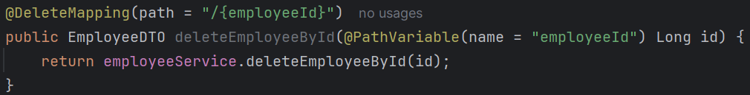
    - Controller method
  - Here I have taken Map<String, Object> instead of EmployeeDTO for the payload.
  - ------------------------------------ @JsonProperty ------------------------------------
    - It should be used in DTO (should not be used in Entity)
    - Whatever field you pass inside @JsonProperty, the incoming payload (request body) should contain that field otherwise it’ll not work.
    - 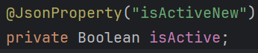
    - Consider this case, the object name is isActive but the @JsonProperty contains isActiveNew.
    - In this case, in the request payload, isActiveNew should be passed instead of isActive like the below:
      - 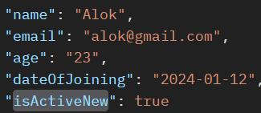
    - Jackson is the one who handles these things.
      - Deserialization : JSON to Java Object
      - Serialization : Java Object to JSON
      - Request body (JSON) to DTO Object (Deserialization) and DTO object to Response body (JSON) (Serialization) is done by Jackson.
    - Using @JsonProperty in Entity has no effect of DB mapping. Even if you write something in @JsonProperty inside @Entity, the DP mapping will only happen on the basis of field name not JsonProperty field name.
    - If you want to specify some column name, then you can use @Column annotation in the Entity. It’ll make the DB column with that particular name.
  - ------------------------------------------------------------------------------------------
- To send the Status Codes, use ResponseEntity
  - 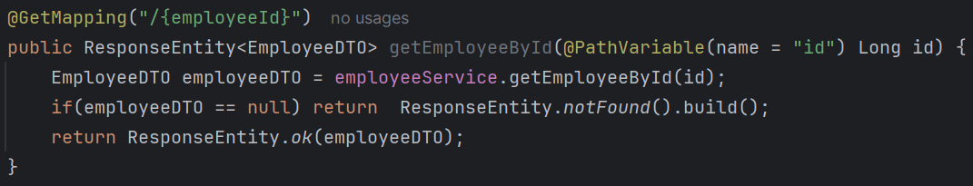
    - This is my implementation. (Controller class)
- The below is proper implementation
  - 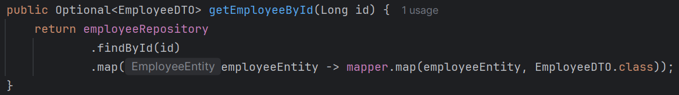
    - Service
    - Optional<T>.map() is just used to convert Optional<T> to Optional<U> type.
      - Here ? super T, ? extends U
      - Here both the “?” are different not same.
    - In our case
      - T : EmployeeEntity
      - U : EmployeeDTO
      - ? Super T : ? is EmployeeEntity
      - ? Extends U : ? is EmployeeDTO
  - 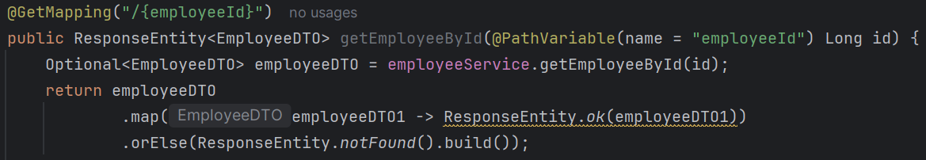
    - Controller
  - Instead of returning EmployeeDTO, it should return ResponseEntity<EmployeeDTO> to send the status code along with response.
  - As the Service method is returning Optional type, so in the Controller method we need to use Optional type variable to handle that.
  - In that, we can also use Constructor reference like below
    - 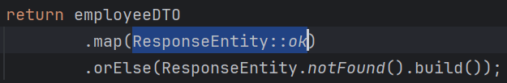
- 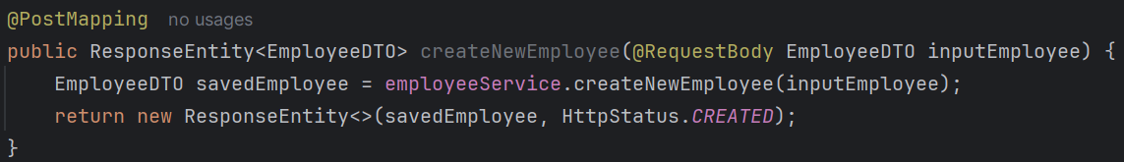
  - In this case we created the object of ResponseEntity and returned here.
  - If we want some custom Http Status Code then we can create one ResponseEntity object and pass our object and the custom status code inside it.

- DeleteMapping
  - 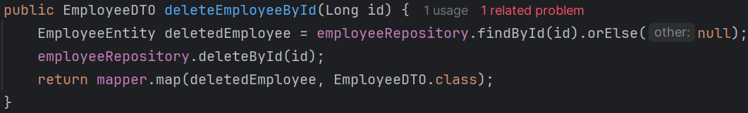
    - Service method to delete the employee.

Input Validation
- spring-boot-starter-data-jpa it is the spring helper package for validating fields.
- Some Annotations for validations are listed below
  - @NotNull
  - @NotEmpty
    - not null and size should be greater than 0;
    - Used in Collections, arrays, string
  - @NotBlank
    - string is not null and trimmed length is greater than 0)
  - @Size
    - element’s size should fall within specified range)
  - @Max
    - annotated element should be a number & less than or equal to provided value
  - @Min
  - @Email
    - Annotated string should be a valid email
  - @Pattern
    - Annotated string should match the specified regular expression.
  - @Positive
    - Annotated element should be a positive number.
  - @PositiveOrZero
  - @Negative
  - @NegativeOrZero
  - @Past
    - Annotated date or calendar value should be in the past
  - @PastOrPresent
  - @Future
  - @FutureOrPresent
  - @Digits
    - Annotated number has up to specified number of integer and fraction digits
  - @DecimalMin
    - Annotated element should >= specified minimum, allowing decimal points
    - 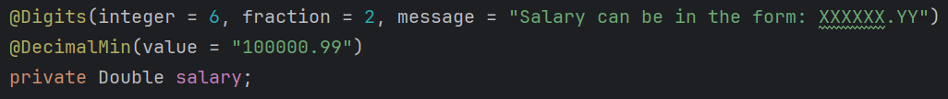
  - @DecimalMax
  - @AssertTrue
    - Annotated field should be boolean and should be true
  - @AssertFalce
  - @Valid
    - Validates the associated object recursively
    - Applies bean validation to nested objects.
- As the first point is DTO, we need to specify the validation at the DTO level
  - 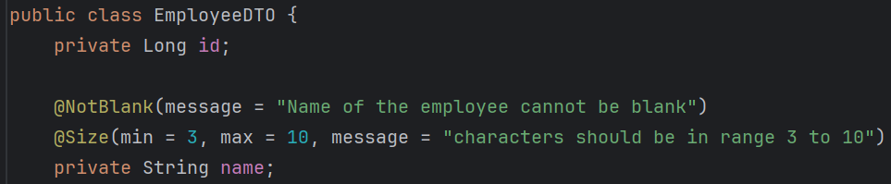
    - Here I gave @NotBlank and @Size for the field name.
  - But giving validation alone in DTO won’t work; you need to mention in the Controller as well.
    - When you write @Valid here then it’ll go and check the validations of DTO.

Annotation
- An annotation is metadata added to Java code to give information to the compiler, tools, or runtime. It does not affect program logic directly but describes how the code should be treated.
- Types:
  - SOURCE
    - Available only in .java file
    - Removed during compilation
    - Used by compiler and IDE
    - e.g., @Override, @SuppressWarnings
  - CLASS
    - Stored in .class file
    - Not available at runtime
    - Default retention
  - RUNTIME
    - Stored in .class file
    - Available at runtime via reflection
    - e.g., custom annotations, @Deprecated
  - RetentionPolicy.SOURCE, RetentionPolicy.CLASS, RetentionPolicy.RUNTIME
- Targets (Where annotations can be applied) ElementType
  - TYPE → class, interface
  - METHOD → method
  - FIELD → variable
  - PARAMETER → method parameter
  - CONSTRUCTOR → constructor
  - LOCAL_VARIABLE → inside methods
  - ANNOTATION_TYPE → another annotation
  - PACKAGE → package-info.java
  - Example: ElementType.METHOD
  - You can give multiple targets as well.
- Spring uses annotation to do everything
  - It scans the annotations using reflection.
  - Create objects and injects according to those
  - For example: clazz.isAnnotationPresent(Component.class) then it’ll create one Bean.
  - It helps it maintain the code clean.

Custom Annotation
- Created one custom annotation to validate the Role of the employee.
  - 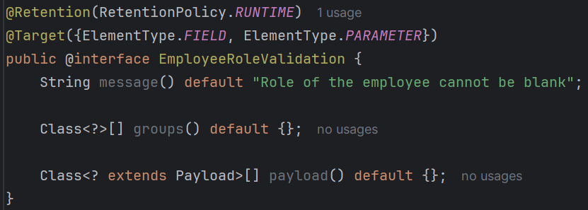
  - Here message means the error message when the validation fails.
  - Rest methods like groups and payload. It’ll be updated later. @TODO
  - So, we created the interface now. But we have to implement the logic to make sure when this validation will be valid and when it’ll be invalid.
- We have to create one class inheriting the interface ConstraintValidator passing the annotation interface and data type that validator will check (in our case String).
  - 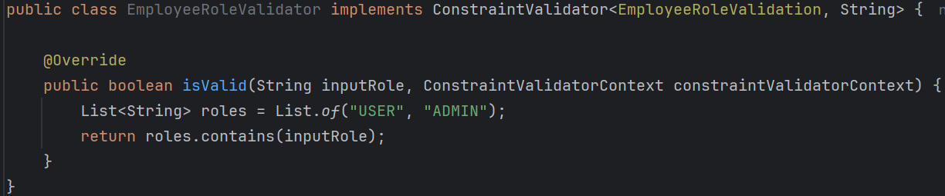
  - And here write the logic of isValid method to validate the constraint.
- Now, we implemented the annotation to validate, and created one validator class to write the validate logic.
  - But, the annotation and validator class are not connected till now.
  - The connection will be build using @Constraint annotation.
  - 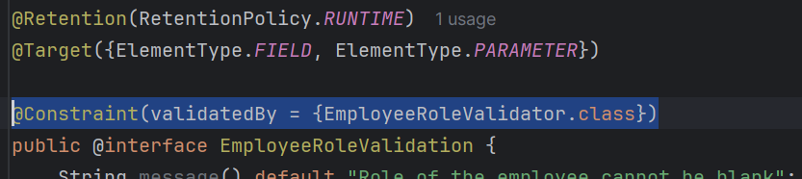
  - Now whenever the custom annotation @EmployeeRoleValidation will be triggered, it’ll go to EmployeeValidator class and run the validation method which is isValid.
  - @Constraint is what tells the Bean Validation (Hibernate Validator) system that your annotation is a VALIDATION ANNOTATION.
- 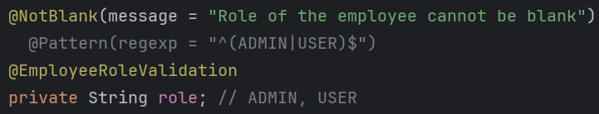
  - Now used the custom @EmployeeRoleValidation annotation in EmployeeDTO to validate the input.
- There are multiple use-cases of annotations, in our case the use case was to validate something.
  - Annotations can be used for Annotations can be used for validation (your case), dependency injection, REST mapping, JSON mapping, database mapping, configuration, logging, security, AOP ..etc
  - 3 types of annotations:
    - Marker Annotations
      - No methods; only used to mark something
      - Ex: @Deprecated, @Override ..etc
    - Single-Value Annotations
      - Have exactly one method (usually named as value)
      - 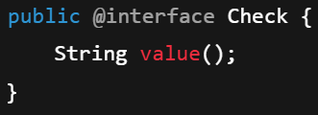
    - Multi-Value Annotations
      - Have multiple methods; most commonly used.
      - 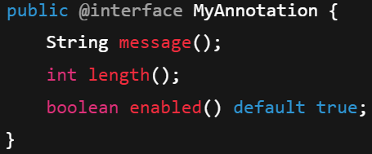
      - @EmployeeRoleValidation was a Multi-Value Annotation.
- Validation Annotation will be multi valued only.
  - You need to give message, groups, payloads though you are not using those.
  - Its related to Java Bean (not Spring Bean)
    - Java Bean means one simple class containing private fields and getters, setters.
    - Spring Bean means Spring Managed Objects .

Custom Exception Handling
- @ExceptionHandler annotation is used to define custom exception handler.
  - 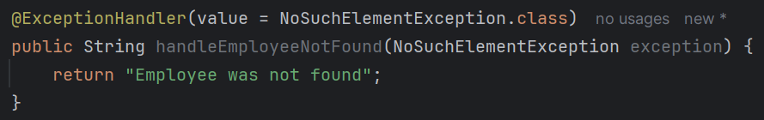
  - Here (in EmployeeController) I created one method using the annotation @ExceptionHandler.
  - This annotation takes the class object of the particular exception that it needs to catch.
  - So now, whenever any NoSuchElementException is thrown from EmployeeController, this method will catch that and handle that.
- Now, we need to throw the proper exception to make the method (Exception handler method) work.
  - 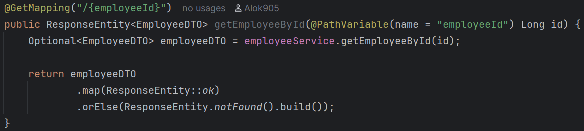
    - This is the previous implementation of our getEmployeeById method.
    - Here we need to throw that exception i.e. NoSuchElementException so that our ExceptionHandler method can handle the particular exception.
  - 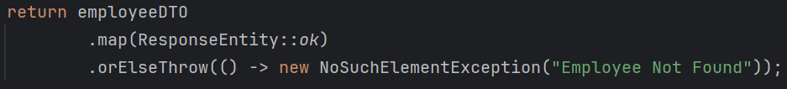
    - It is an optional class’s method and it expects to return one Exception object.
    - Don’t write throw new NoSuchElementException(“…bla bla…”) here.
- In the previous implementation of exception handler method, we are not returning the ResponseEntity so that even if the request fails, it’ll give status code 200.
  - 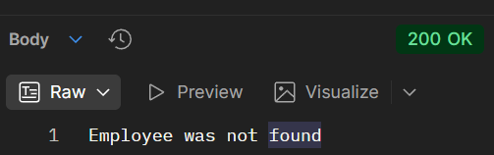
  - So we need to return ResponseEntity instead of String.
- 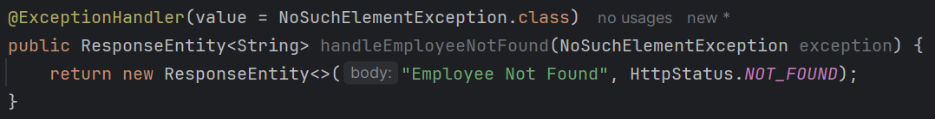
  - Now the status code will be sent properly.
  - 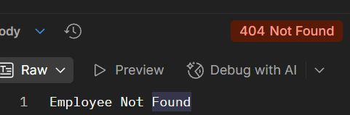
- We have one catch here
  - This exception handler is only handling the exception of EmployeeController; but we want one method that will handle exceptions globally.
  - @RestControllerAdvice is used to write logic that will apply globally for all @RestController classes. (not just Exception Handling)
    - It is basically @RestController + @ControllerAdvice
  - 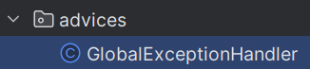
    - Here I created one class GlobalExceptionHandler
  - 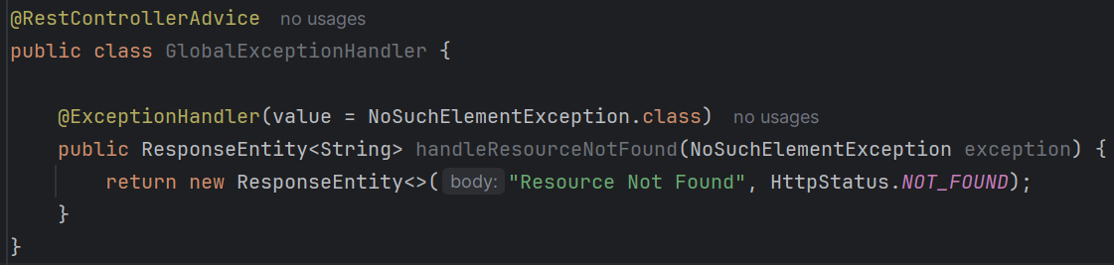
  - Created one ApiError class inside that Service directory
    - 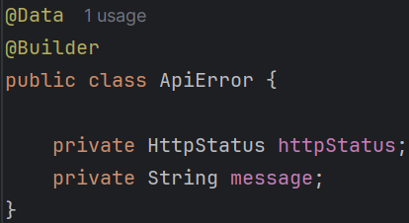
    - @Data is lombok annotation that is combination of @Getter @Setter and so many.
    - @Builder is also lombok annotation that allows you to create an object without using constructor. And provide chaining like the below
      - 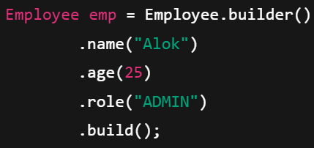 (just example)
      - 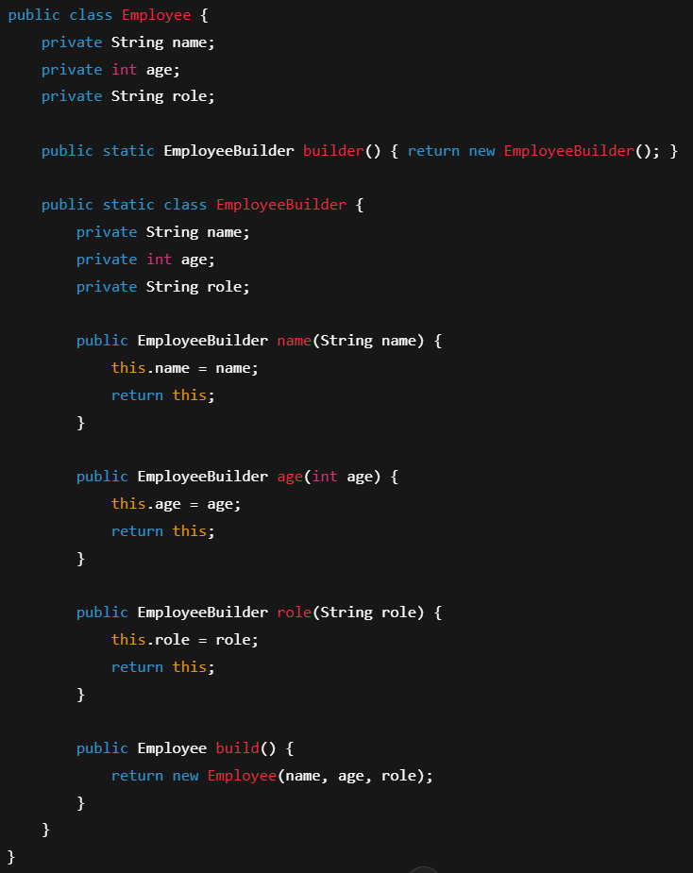
      - It’ll be like this under the hood.
      - You need to call builder() in the beginning, build() at the end to create the object.
  - 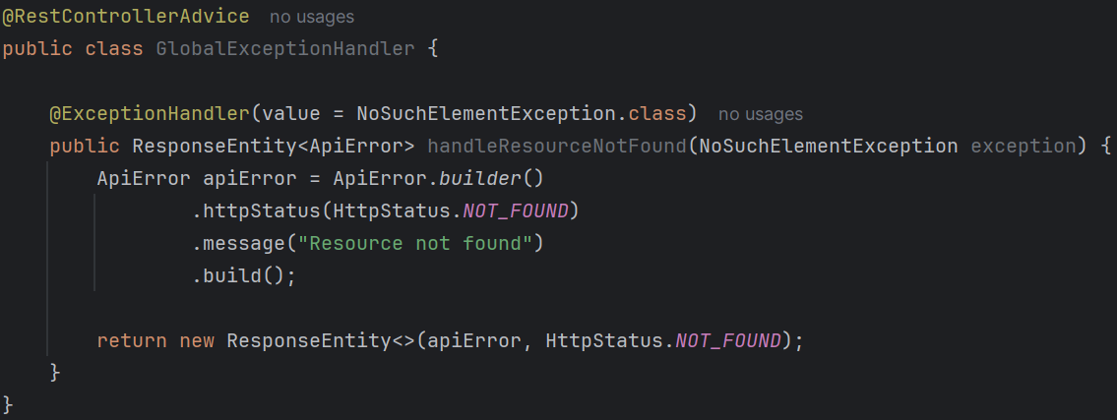
    - Now the error response will be well formatted.
  - 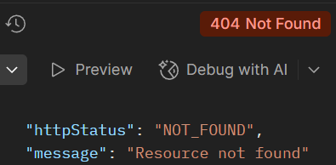
    - Now you’ll get a proper formatted response.
- Refactoring of the codes:
  - Instead of using NoSuchElementException, we should create our own Exception.
    - (create one package exceptions and write your own exceptions inside that)
    - 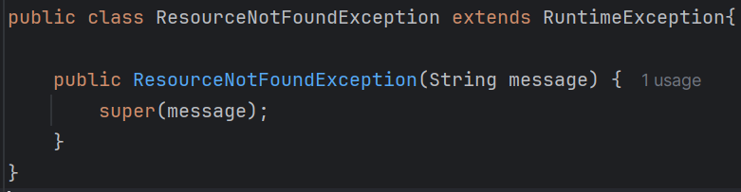
  - Instead of writing some fixed error message, we should use exception.getMessage()
    - 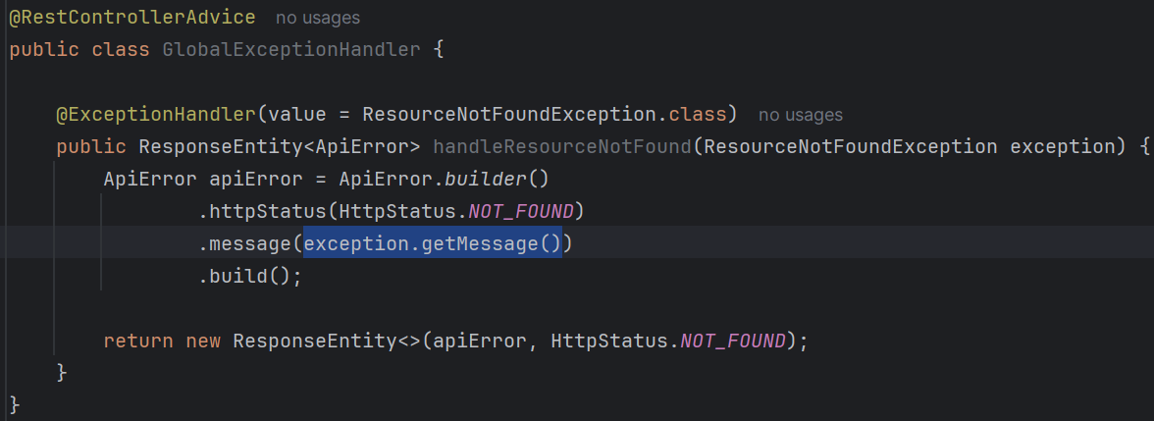

- Created one exception handler for all those exceptions which are not being handled yet by giving the parent Exception class’s object.
  - 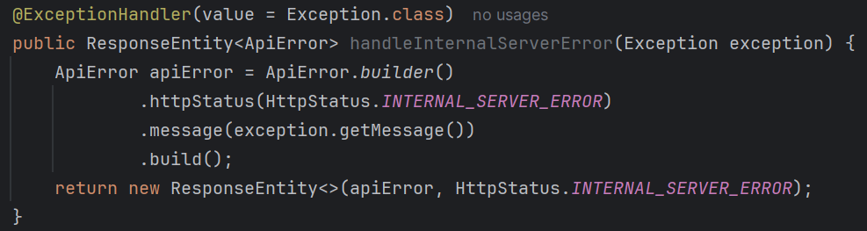
  - But it’ll give the response with some messy messages where the input validation failed. (with the validation annotations)
    - 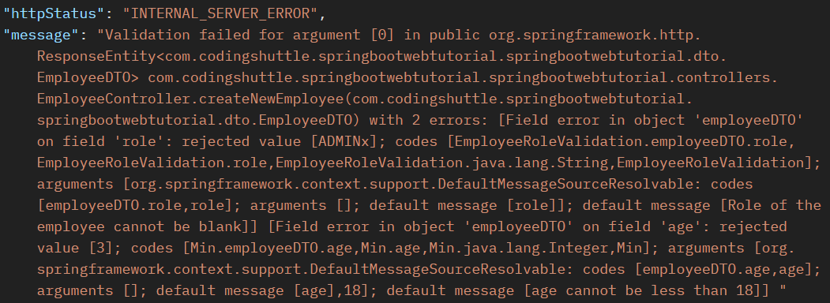
- Created one more exception handler for the MethodArgumentNotValidException
  - This exception is thrown for failure of validation annotations.
  - 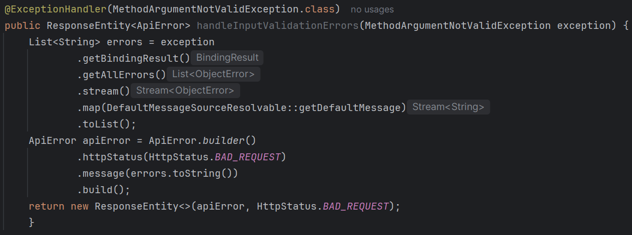
  - Now it’ll come proper
  - 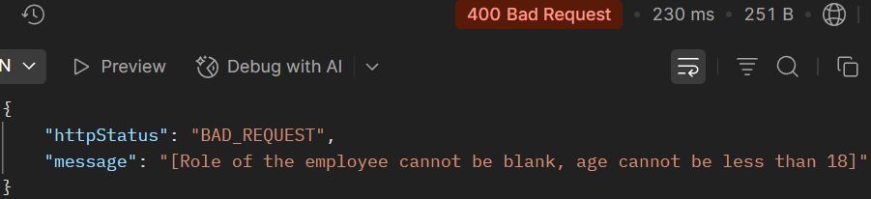

Transforming API responses Globally
- Before this lets learn about @RestControllerAdvice
  - It is used to apply GLOBAL logic to ALL @RestController classes.
  - The use-cases are given below:
    - Exception Handling (most common use-case)
      - In this case, no need to inherit any class/interface.
    - Global Response Body Modification
      - In this case, implement ResponseBodyAdvice interface.
    - Global Request/Response Binding Configuration
- How?
  - Extend your class with @ResponseBodyAdvice<Object> to define the custom return type.
  - Use @RestControllerAdvice for global API response transformation
  - Return appropriate HTTP status codes and error messages.
  - You can also return the timestamp of the API response.
  - Here you need to implement ResponseBodyAdvice interface passing Object as the type.
- Inside ResponseBodyAdvice, 2 abstract methods are there
  - supports() and beforeBodyWrite()
  - boolean supports(returnType, converterType)
    - Depending upon the returnType and converterType (html, json, string etc) you can choose to use the method beforeBodyWrite()
    - If you return false from support() method, then beforeBodyWrite() method will not be used.
    - If you return true from support() method, then beforeBodyWrite() method will be used.

- Create one ApiResponse class inside advices directory which will be the global API response format
  - 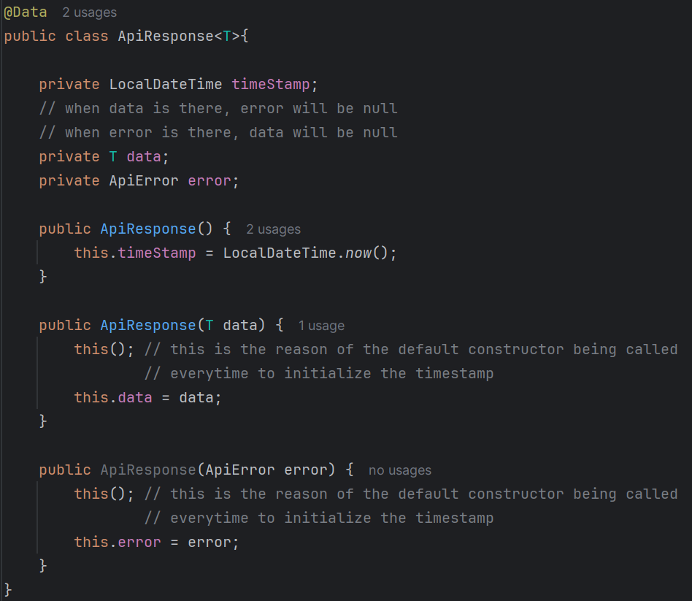
- And update the beforeBodyWrite method
  - 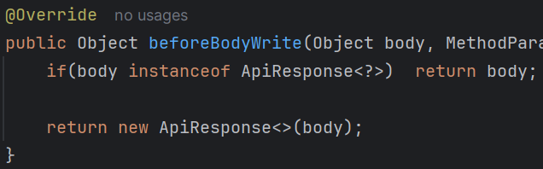
- NOTE
  - The response from Exception handler and Rest controller methods contains header i.e. ResponseEntity but when it reaches to the response handler’s beforeBodyWrite method, only the body of the response is being passed here. Not with the ResponseEntity.

- Flow of Exceptions and Response ----------------------------------------------------------
  - Whenever any error is thrown from any controller method, it’ll find any class having @RestControllerAdvice which is having @ExceptionHandler methods, then it’ll trigger that method.
    - Now you can say, if @ExceptionHandler method is only needed, then to create the bean of the class, we can simply use @Component instead of @RestControllerAdvice.
    - But it’ll not work because Spring only check classes annotated with @RestControllerAdvice or @ControllerAdvice.
  - After the exception handler method’s work is finished, it’s returned object will be sent to @RestControllerAdvice class which is implementing ResponseBodyAdvice interface.
    - If there was no exception, then it’ll skip the exception handler class, and directly comes to Response handling class.
  - Now, whatever you want you can do in this class and return the response. That’ll go to the user as response.
  - 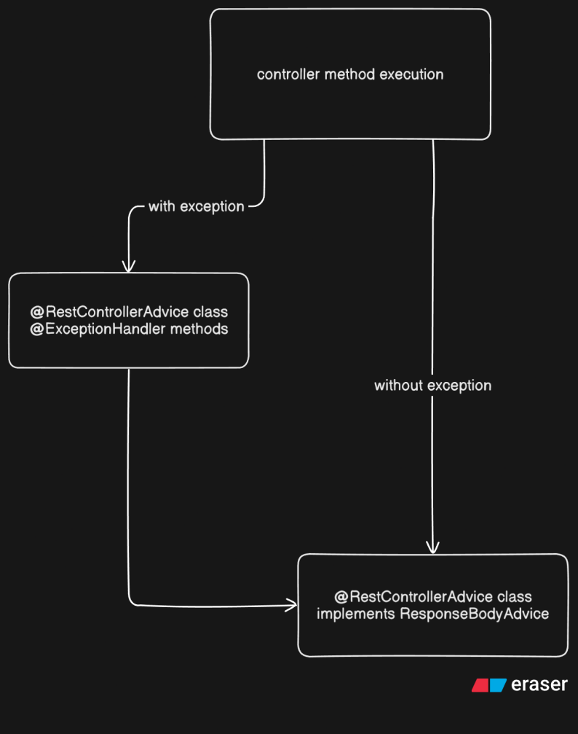
  - ------------------------------------------------------------------------------------------

- So, we were returning ApiError type of object from exception handler and ApiResponse type of object from response handler.
  - So, in case of exception, it the ApiError object was being passed to response handler as the data.
  - So, the output was not proper
    - 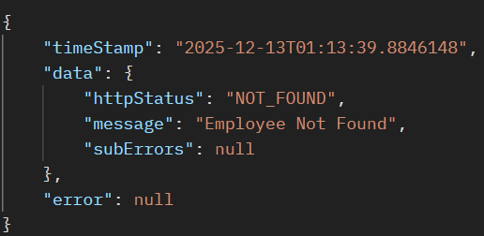
    - error should contain those error data. And data should be null.
  - 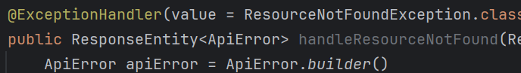
    - Instead of sending ApiError object, we can send ApiResponse object as ApiResponse has one property already there of type ApiError.
    - 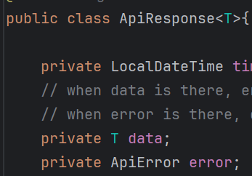
  - And also, in response handler, we have written the condition that if the object is of type ApiResponse then return the object directly.
    - So if we return ApiResponse type of object having data=null and error will be error data, then it’ll send the proper response to the user.
    - 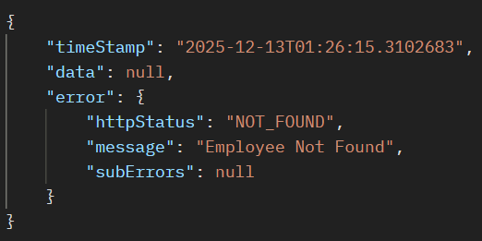
    - Now its coming properly

Annotations that were being used in this module
- Controller Layer
  - @RestController : make the class Rest (@Controller + @ResponseBody)
  - @RequestMapping : define common end point
  - @GetMapping, @PostMapping, @PutMapping, @DeleteMapping, @PatchMapping
  - @PathVariable : get the URL param (you can change the name as well)
  - @RequestParam : get the URL query values
  - @RequestBody : Request payload will be get (type will be DTO)
  - @RestControllerAdvice : creating class for handling global exceptions.
  - @ExceptionHandler : used to create exception handler methods
- Service Layer
  - @Service : to create the service
- Repository Layer
  - @Repository : to create the repository (it should also inherit JpaRepository)
- Entity / JPA
  - @Entity : to create Entity (entity is nothing but the schema of SQL table)
  - @Table : to give custom name to Database table
  - @Id : high-level annotation used inside Entity to make the field Primary-Key
  - @Column : to give custom name to the column.
  - @GeneratedValue : used in case of id, to specify type of increment of ids.
- Jackson
  - @JsonProperty : used for Serialization (obj to json) and Deserialization (json to obj)
- Lombok
  - @Data : combination of @Getter, @Setter and so many annotations.
  - @Builder : used to create object of class without using constructor.
- Custom Annotation
  - @Target : specify the target(s) like class, methods, fields, parameters etc.
  - @Retention : when to use annotation (pre-compile, runtime, post-compile)
  - @Constraint : used in case of validation annotation to map the validator class.
    - Validator class should inherit ConstraintValidator

